DC MOTOR CONTROLLING SYSTEM
INTRODUCTION:
Now a days DC motors plays a vital role in most of the industrial areas, it can be seen in most of the electronic devices. They are mainly used for the mechanical movements of physical applications such as rolling the bundle of sheets or CD drives, lifts etc.
Many methods evolved to control the revolution of a motor. DC motors can be controlled either by software or directly by hardware. Software controlling needs computers which are bulky and common man cannot afford for it, so hardware controls are in use. Even in hardware if it is programmable device then it is preferred because it can be modeled according to the requirements of the user.
Advantages of using PIC over other controlling devices for controlling the DC motor are given below:
1. SPEED: The execution of an instruction in PIC IC is very fast (in micro seconds) and can be changed by changing the oscillator frequency. One instruction generally takes 0.2 microseconds.
2. COMPACT: The PIC IC will make the hardware circuitry compact.
3. RISC PROCESSOR: The instruction set consists only 35 instructions.
4. EPROM PROGRAM MEMORY: Program can be modified and rewritten very easily.
5. INBUILT HARDWARE SUPPORT: Since PIC IC has inbuilt programmable timers, ports and interrupts, no extra hardware is needed.
6. POWERFUL OUTPUT PIN CONTROL: Output pins can be driven to high state, using a single instruction. The output pin can drive a load up to 25mA.
7. INBUILT I/O PORTS EXPANSIONS: This reduces the extra IC’s which are needed for port expansion and port can be expanded very easily.
8. INTEGRATION OF OPERATIONAL FEATURES: Power on reset and brown/out protection ensures that the chip operates only when the supply voltage is within specification. A watchdog timer resets PIC if the chip ever malfunctions and deviates from its normal operation.
BASIC IDEA
There are two types of DC motors, unidirectional and bidirectional. Unidirectional rotates in only one direction and it is specially meant for some specific applications while the bidirectional can be rotated in the clock-wise or the anti-clockwise direction. This the most widely used for industrial applications. There are two parameters to be considered in controlling the movements of a DC motor.
1. DIRECTION.
2. SPEED.
The first thing that can be controlled in a motor is its direction of rotation. Direction of the motor can be controlled by controlling the polarity of the current flowing through it. Usually a DC motors are driven by famous H-Bridge circuits made up of either transistors or the buffers or any other suitable methods.
Controlling the speed of the motor is another important area to be considered. The speed of motor is directly proportional to the DC voltage applied across its terminals. Hence, if we control the voltage applied across its terminal we actually control its speed.
A PWM (Pulse Width Modulation) wave can be used to control the speed of the motor. Here the average voltage given or the average current flowing through the motor will change depending on the ON and OFF time of the pulses controlling the speed of the motor i.e.. The duty cycle of the wave controls its speed.
This project is developed with a PIC IC 61F84A, which is programmable. The word PIC stands for PERIPHERAL INTERFACE CONTROLLER, a single chip microcontroller is developed by Microchip technology.
HARDWARE DESCRIPTION
BLOCK DIAGRAM OF THE DC MOTOR CONTROLLING SYSTEM
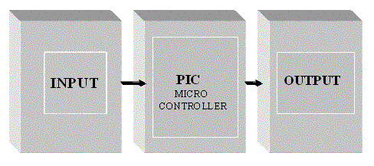

The block diagram of the circuit is shown above. This circuit controls the speed and direction of the motor. The PWM (Pulse Width modulation) output from the four port pins is given to the H-Bridge circuit which drives the motor. On changing the duty cycle (ON time), we can change the speed. By interchanging output ports, it will effectively change direction of the motor.
The PIC microcontroller is the brain of the circuit controlling all actions to be done. Inputs are given to control the speed and direction of the motor. The PIC output controls the DC motor.
The circuit consists three parts:
1. INPUT
2. PIC MICROCONTROLLER
3. OUTPUT
1. INPUT:
There are two inputs. One for direction control and the other for speed control.
These generates interrupts for the PIC which are used for controlling the speed and direction.
There are 2 interrupts used as control signals for the PIC.
a. External interrupt.
b. PORTB input (interrupt on change).

Interrupts deviates the main program execution to interrupt subroutines (ISR) and return to the main program. The global enable bit in the INTCON register will allow all interrupts to occur. This will reset on going to ISR and set when coming out of it.
An interrupt on external interrupt pin will set flag INTF in the INTCON SFR(Special Function Register). At the same time the program execution is deviated to the ISR where there is a register used to controls the movement of direction (clockwise or anti-clockwise). An interrupt on portB 4 (4/5/6/7) pin will set flag RBIF in the INTCON SFR(Special Function Register). Meantime the program execution is deviated to the ISR, where there is a register used to control the speed of the motor (maximum or minimum).

2.PIC MICROCONTROLLER
It is used to control the rotation of the motor. This senses the input and process it using the program burned in it and gives the required PWM output on the required port pins. The program is given later. To control the speed we need to control the duty cycle (‘ON’TIME / PERIOD). That is controlling the ON time. In the program we have used a timer (TIMER0), this timer can be used as variable delay generator to control the ON, OFF times. Also the prescalar can be used to change the varying ON time because it provides internal timing for program execution. We have made use the prescalar to control the PWM output which in turn controls the speed. Initially timer0 is set with some value and some prescalar. When it overflows it generates an Interrupt. This sets TOIF flag in the INTCON register. At the same time the program execution is deviated to the ISR. Here a register is used to control the varying time and to shift alternatively to send high and low as output. This is nothing but the PWM output.
3.OUTPUT
The output from the portA is given to the H-bridge. It is the arrangement of four transistors as shown below. Here four power transistors 2N3055 are used (Q1,q2,Q3,Q4). At any time either Q1, Q3 or Q2, Q4 are made ‘ON’, hence current flows from the source (Vdd) to ground (Vss) through the motor. The direction of the motor is dependent on the polarity of the current. Hence by changing the ‘ON’ transistor pairs we can control the direction of the motor. To ‘ON’ the transistor we need to give high to its base. On controlling output coming out of port we can achieve the control over the motor rotation direction.

H BRIDGE CIRCUIT
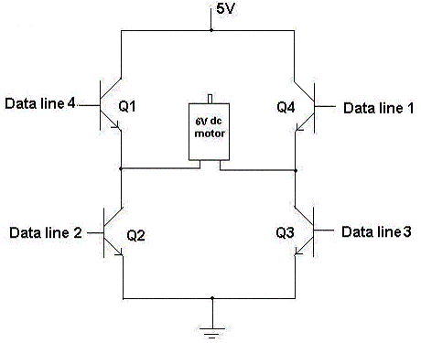
PIC 16F84A IC PIN DIAGRAM
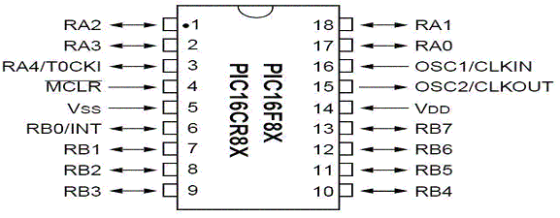

WORKING OF THE CIRCUIT
THE SIMPLIFIED CIRCUIT DIAGRAM
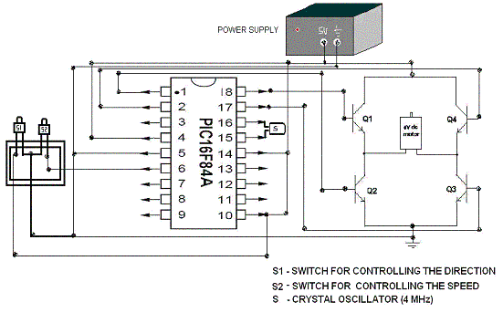

The circuit is built around the PIC IC 16F84A. The circuit is built as shown above. The power supply of 5V and ground is given to appropriate pin of the PIC IC and to the H Bridge circuit. A 4M Hz crystal oscillator (S) is connected as shown in the figure. Other type of oscillators can also be used. The crystal oscillator is more stable compare to other types. Oscillator acts as a clock source for the PIC IC operation.
The portB’s four pins are given to the H-Bridge as shown in the figure. These pins are the control lines (PWM output lines) given to H-Bridge to rotate in the desired direction and desired speed.
To change the direction and speed we need two buttons S1, S2. These buttons are one side grounded and the other sides are connected to the pin of the appropriate port of the PIC IC. On pressing the button S2 the speed is shift between minimum and maximum .On pressing the button S1 the direction of rotation is changed either clockwise or anti-clockwise.
FURTHER DEVELOPMENT
On varying the prescalar of the PIC we can achieve different speeds. For controlling this speed we need to add extra instruction in the ISR. There are still 3 pins left in the PORTB which can be used for the control of these speeds.
To handle a motor which requires more power, high power transistors or power amplifiers can be used.
This is the method by which we can control the motor direction and speed digitally. This allows us to control the motor without a direct wire connection between control unit and the motor driving circuit. By using appropriate communication method this can be achieved.
APPLICATIONS
This project is built with the PIC IC. Hence become more compact. Here the speed and direction are controlled digitally. Hence wireless communication between the controller and the dc driver is possible by adopting suitable methods. This project can be used wherever there is a DC motor. The controlling becomes very easy because a very small circuitry is sufficient.
This can be used in any industrial applications and in electronic devices, where a DC motor control is significant.

SOFTWARE
list p=16F84A
#include "p16f84A.inc"
__CONFIG _CP_OFF & _WDT_OFF & _PWRTE_ON & _XT_OSC
cblock 0x0c ;Declaring variables
count
level
sel_delay
dir
endc

;************************* MACRO **************************************
send1 macro dir ;Macro for sending high to portA
banksel PORTA
btfsc dir,0 ;If dir=0 rotate CLOCKWISE else ANTI-CLOCKWISE
goto next16
goto next15
next15:bsf PORTA,0 ;Setting or Resetting the PORTA pins
bsf PORTA,1 ;For CLOCKWISE direction
bcf PORTA,2
bcf PORTA,3
goto next19
next16:bcf PORTA,0 ;Setting or Resetting the PORTA pins
bcf PORTA,1 ;For ANTI-CLOCKWISE direction
bsf PORTA,2
bsf PORTA,3
goto next19
next19:
ENDM
send0 macro ;Macro for sending low to portA
banksel PORTA ;Resetting the PORTA pins done here
bcf PORTA,0
bcf PORTA,1
bcf PORTA,2
bcf PORTA,3
ENDM
org 0x00 ;Reset vector address
goto MAIN ;Begining of main programm
org 0x04 ;Interrupt vector address
goto int_service ;Beginig of interrupt routine

;************************ MAIN PROGRAM ********************************
MAIN
banksel TRISA ;Select BANK1
movlw 0x00
movwf TRISA ;Set PORTA as output port
movlw 0xff
movwf TRISB ;Set PORTB as input1
movlw 0x00 ;Regester for indicating 1 or 0 for PORTA pins
movwf level ;By default high is sected
banksel PORTA
movlw 0x03
movwf PORTA ;Initialise PORTA (pin 0,1) as high
movlw 0x37
movwf TMR0 ;Initialise TIMER0
movlw 0x00 ;Regester for indicating SPEED of motor
movwf sel_delay ;By defult maximum speed is selected
movlw 0x00 ;Regester for indicating DIRECTION of motor
movwf dir ;By default ANTI-CLOCKWISE is selected
banksel INTCON ;Enable PORTB(bit3=0)EXTERNAL INTERRUPT(bit4=0)
movlw b'10111000' ;TIMER0 (bit 5=0) interrupts
movwf INTCON
loop:
banksel OPTION_REG
btfsc sel_delay,0;If el_delay=0prescaler=1:256 else prescaler=1:1
goto next20
goto next21
next20:
banksel OPTION_REG ;Intialise OPTION_REG with 000 for TIMER0
movlw 0x00 ;Prescaler=1:1 ,and bit 7(=0) for activating
movwf OPTION_REG ;"PULL UP" resistor of the PORTB
goto end_rt
next21:
banksel OPTION_REG
movlw 0x07 ;Intialise OPTION_REG with 111 for
movwf OPTION_REG ;TIMER0 prescaler=1:256
goto end_rt
end_rt:
goto loop ;Main programm ends here

;***************** INTERRUPT SERVICE ROUTINE **************************
int_service
banksel PORTA ;Select BANK0
btfsc INTCON,2 ;Check for TIMER0 overflow interupt
goto isr_time ;if occured goto TIMER0 ISR
btfsc INTCON,0 ;Check for PORTB(Pin 4/5/6/7)interrupt
goto isr_prtrinc ;if occured goto PORTB ISR
btfsc INTCON,1 ;Check for EXTERNALINTERRUPT (RB0/INT)
goto isr_direct ;if occured got EXTERNAL ISR

;///////////////////// TIMER OVERFLOW ISR /////////////////////////////
isr_time:
btfss level,0 ;If level=0 (bit 0) call send0 macro
goto next4
decf level,1 ;Else update level
banksel TMR0 ;Select BANK0
movlw 0xc8
movwf TMR0 ;Initialise TIMER0 with 'ON' time
send1 dir ;send HIGH to PORTA pins (MACRO)
goto end_isr
next4:
banksel TMR0
movlw 0x37 ;Initialise TIMER0 with 'OFF' time
movwf TMR0
send0 ;Send LOW to PORTA pins (MACRO)
banksel PORTA
incf level ;Update level
goto end_isr

;///////////////////// PORTB ISR //////////////////////////////////////
isr_prtrinc:
banksel PORTB ;If there is an Interrupt on PORTB Pin 4
btfsc PORTB,5 ;Alternativelly select max. and min. speed
goto end_isr
incf sel_delay,1 ;sel_delay(bit0)changes to 0and1 alternatively
goto end_isr

;///////////////////// EXTERNAL ISR ///////////////////////////////////
isr_direct:
banksel PORTB ;If INTERRUPT on RB0/INT pin occured
btfsc PORTB,0 ;Regester dir = 0 for CLOCKWISE ROTATION
goto end_isr ; dir = 1 for ANTI-CLOCKWISE ROTATION
incf dir,1 ;Incriment Direction regester (bit0=1)
goto end_isr
end_isr:bcf INTCON,0 ;Clear PORTB INTERRUPT FLAG
bcf INTCON,1 ;Clear TIMER OVER FLOW FLAG
bcf INTCON,2 ;Clear EXTERNAL INTERRUPT FLAG
retfie ;Return from ISR enabling GLOBAL INTERRUPT FLAG
END ;END OF THE PROGRAMM

